POLYMERS AND PLASTICS

The purpose of this experiment is to introduce basic concepts of polymers and plastics. The experiment includes some of the basics of polymer science, the role of the mechanical properties of polymers and plastics in applications, and aspects of their degradability.

Introduction:

Mechanical properties are important in the applications of plastics. In this experiment you will observe how tensile properties of plastic films, cast from polymer solutions, depend on the formulation of the material.

In many applications it is desirable that the polymer materials be degradable and in some cases biocompatibility is desirable¹. [Other applications may require materials that are biocompatible and non-degradable, such as long-term polyethylene implants.] There is actually a growing use of biodegradable and compostable polymers and plastics for large-scale commodity applications, such as trash bags and food service items (forks, spoons, cups, plates) for the fast-food industry, as well as for home use. The development of biodegradable plastics and compostable plastics is partially being driven by waste-managements issues and concern for the environment. If the plastics are also derived from renewable biomass they conserve nonrenewable fossil resources.

Polymers and Plastics

Polymers are formed by linking large numbers of small molecules (monomers) together, often resulting in parts of the structure containing many repeating monomer units. The monomer unit, the length of the polymer chains, and the degree to which chains are cross-linked, controls the material properties of polymers. Polymers can be synthetic or biological. Synthetic polymers are almost always made from nonrenewable fossil feedstocks, mainly petroleum. Examples are polyethylene, polystyrene, poly(vinyl chloride), and polypropylene, all of which are polyolefins. Poly(ethylene terephthalate) [PET] is a synthetic polyester. None of the above-named polymers are degradable, the main reason being that the polymer backbones contain only carbon-carbon single bonds. Examples of biodegradable polymers derived from petroleum are poly(vinyl alcohol) [a polyalcohol], poly(ethylene glycol)[a polyether], and the polyesters polycaprolactone and poly(glycolic acid). Polymers with heteroatoms in their backbones are generally biodegradable, although there are exceptions.

Biological polymers (biopolymers) are found in nature; they are intrinsically biodegradable. Abundant biopolymers include plant polysaccharides such as starch (composed of amylose and amylopectin), cellulose, agarose, and carrageenan, and animal polysaccharides, such as chitin and the glycosaminoglycans. Abundant proteins include collagen/gelatin, casein, keratin, and fibroin.

Microorganisms produce polyesters, a process that in effect stores energy and carbon. Commercial bacterial polyesters are the polyhydroxyalkanoates, including polyhydroxybutyrate, polyhydroxyvalerate, and the copolymer poly(hydroxybutyrate-co-valerate). They are produced by fermentation; the particular polyester produced depends on the microbial strain being used and the growth substrate.

Poly(lactic acid) (PLA) is an example of a synthetic commercial polymer in which the monomer, lactic acid, is produced in large amounts through fermentation, and the polymer produced by conventional synthetic methods. PLA is biodegradable.

A plastic is a material that contains one or more organic polymeric substance of large molecular weight. Also, plastics almost always contain additives that give the plastic desirable properties, such as plasticizers that act as softening agents. The bulk polymeric material, called resin, is processed to produce three-dimensional shapes or films. Examples of common engineering processes are extrusion, film casting, or molding.

Plastics are of two types. Ninety percent of plastics are thermoplastics, which can be repeatedly softened and re-softened; their polymer chains are generally linear or slightly branched. Thermosets cannot be reworked after curing; their chains are highly cross-linked in the curing process. An example is epoxy resin.

Coatings (including paints), elastomers (rubbers), and fibers are also made from polymers and the same polymer is sometimes used to manufacture both plastics and fibers. For example, poly(ethylene terephalate), which is used to make plastic water and soda bottles, is also processed into fibers from which permanent press polyester (Dacron) fabrics are manufactured.

Plastics are formulated and processed to produce properties appropriate for the intended application. Test methods for measuring plastics properties are standardized to produce uniformity within the plastics industry. In the United States, standardization of test methods is the responsibility of the American Society for Testing and Materials (ASTM). Over 500 test methods have been developed for plastics alone, covering a wide range of properties².

The mechanical properties of plastics are exceedingly important. For example, in biomedical applications, the mechanical properties of implants and wound healing materials are important. In this experiment you will carry out tensile tests³, tests in which specimens are placed between two clamps (grips) and drawn. The instrument measures and displays the force being applied (the load) and the increase in the length of the sample (elongation, also called extension).

From the dimensions of the film specimen (width and thickness), the instrument software calculates and displays the tensile stress (σ), equal to the load (F) per unit area of cross section (A = width x thickness).
It also calculates the (tensile) strain (ε), equal to the elongation (extension) divided by the original length of that portion of the specimen being measured (called the gauge length). [In our experiment, the gauge length is simply the separation of the grips securing the specimen.] The instrument will display percent elongation, which is the strain multiplied by 100.
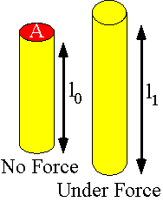

As the test proceeds, the instrument generates and displays a tensile stress-strain curve, which is a diagram that displays values of tensile stress (in MPa) plotted against tensile strain (%). The test continues until the specimen breaks.

From the stress-strain curve, the software determines, and reports the following results in table form:
(1) tensile strength at break (or ultimate strength), which is the tensile stress at break.
(2) elongation at break, as a percentage
(3) Young's modulus (also known as elastic modulus or modulus of elasticity or sometimes simply as "modulus"). It is calculated as the initial slope of the stress-strain curve, which is usually observed to be linear with plastic films. This initial, linear region reflects the elastic deformation of the specimen, in which the stress varies linearly with strain, analogous to Hooke's law for the expansion of a spring. Beyond the linear region, the behavior is termed viscous; polymers and plastics are said to be viscoelastic materials. Modulus is a measure of the "stiffness" of the polymer/plastic.

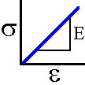

Table 1. Typical tensile properties of materials

Material | t.s.(MPa) | elong.(%) | modulus(MPa)
polyethylene, low density | 10 | 620 | 166
polycaprolactone | 26 | 600-1000 | 435
Polypropylene | 36 | - | 1380
poly(lactic acid),  biaxially oriented film | 110/145 | 160/100 | 3310/3860
keratin(human hair) | 526 | 46 | 6700
copper, annealed | 240 | 30 | 100,000-130,000
Steel | 380-700 | - | 200,000-250,000
Glass | 2160-4830 | - | 50,000-70,000

Encyclopedia of Chemistry, 4th ed.; Handbook of Physics, 2nd ed.

Although we will not be concerned with the measurement of viscous properties of plastics, the combination of viscous and elastic properties of plastics gives plastics their unique qualities. Consider the amusing “silly putty” substance, a plastic. A ball of silly putty can be made to bounce almost like a ball, perhaps with slightly less “bounce.” However, the material can be “worked” into whatever form may be desired, a characteristic of a very viscous liquid. Models of the mechanical properties can be made from spring elements⁴,
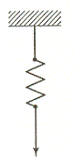

and viscous elements like a shock absorber.
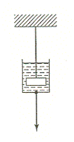
The plastic viscoelasticity may be modeled from parallel, series, or even more complex combinations of these two elements.

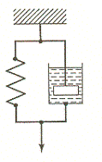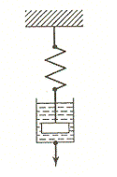
It is possible to make so-called measurements of the viscous and elastic properties directly from “creep” curves of the time dependence of strain for a material with a constant stress applied. Creep curves are shown here for three starch-agar plastic specimens.

A familiar everyday example of the viscous behavior (creep) of plastics occurs with the irreversible stretching of the plastic grocery bag filled with a heavy (constant) load.

In general, polymers⁵⁻⁷ in a state of equilibrium exist as a mixture of crystalline and amorphous regions at low temperatures. See figure below.

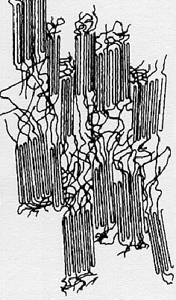

The ability of a polymer to fold back and forth upon itself to form regularly, spatially repeating regions depends on polymer structure. In an extreme example, the irregularly repeating conformations of the monomer units in atactic polystyrene (see structure below) inhibit the formation of any crystalline regions and the polymer is 100% amorphous.
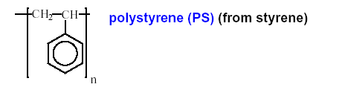

What then imparts the ability of a polymer to exhibit both viscous and elastic properties? It is clearly not the crystalline regions, whose spatially regular packing does not allow for appreciable elasticity and whose crystallinity is generally inconsistent with viscous flow. Completely amorphous polymers exhibit viscoelasticity. The phenomena are often explained in terms of familiar macroscopic, entangled collections of objects such as spaghetti or a ball of snakes. (See Macrogalleria website, http://www.psrc.usm/edu/macrog/tg.htm.)

Let us examine these analogies more closely. When the ball of snakes is cold and relatively immobile, it can be picked up en masse and stretched to a degree without disentanglement. Thus the ball of snakes exhibits strong elasticity with little viscous flow. The same might be said of stale, cold, slightly dried-out spaghetti. On the other hand, on a warm day when the ball of snakes is writhing, the ball could be separated more readily without damage to the snakes, if done gradually. Under these conditions the ball exhibits largely viscous flow with a small degree of elasticity. The fresh warm spaghetti is likewise easily separated gradually. The hint of temperature dependence in these analogies is actually very appropriate.

One of the most revealing experimental techniques for these polymer properties is differential scanning calorimetry (DSC). (See the Macrogalleria website, http://www.psrc.usm.edu/macrog/dsc.htm.) The viscoelastic property is revealed as a second order phase transition, whose temperature, T_{g} (glass transition temperature), roughly characterizes the transition from elastic behavior below T_{g} to viscous flow above T_{g}. See figure below⁸.

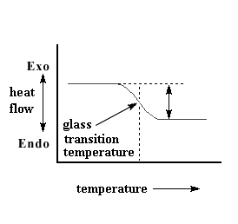

The second order nature of this transition signifies a change in the heat capacity, C_{p}, of the material. See right-hand side of figure below⁹.

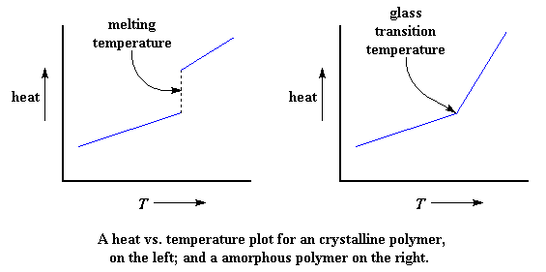

Below T_{g}, C_{p} is due to the excitation of the molecular vibrations and the phonon modes of the polymer chains and the material as a whole. Above T_{g}, C_{p} additionally depends on excitation of the liquid-like “slithering” movements of the entangled polymer chains.

Crystalline materials also undergo the well-known phase transitions of melting and freezing. These transitions are first order transitions, at whose temperature there is a latent heat of melting or freezing. For ordinary pure substances of small molecular size, the freezing (T_{f}) and melting (T_{m}) temperatures are identical. See left-hand side of the figure above⁹.

Not surprisingly, the crystalline regions in a polymer exhibit similar phenomena in polymer DSC traces. However, due to hysteresis effects (supercooling and superheating) T_{f} and T_{m} may be observed at different temperatures. The energies required to break up the strong molecular attractions of the crystalline regions are greater than the energies required to excite the liquid-like “slithering” movements of the entangled chains. Thus T_{f} and T_{m} are usually found at higher temperatures than T_{g} in polymers. (In polymer science T_{f} is sometimes called T_{c}, for crystallization.) See Figure below⁹.
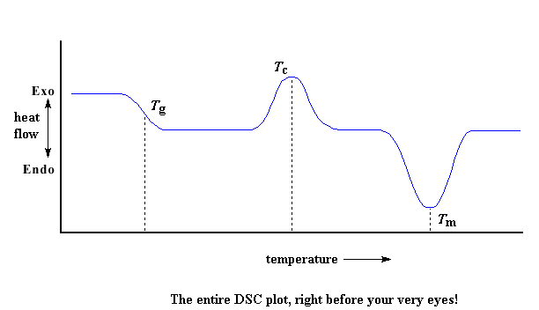

Thus the crystalline regions are undergoing transitions to or from the viscous “phase” of the amorphous region and not to the elastic “phase.”

In this laboratory you will perform, among others, an experiment in which the polymer (agar)-plasticizer (glycerol) ratio is varied systematically. The agar structure is given below.

H

You will be asked to discuss this dependence. In order to do so, a further understanding of the role of a plasticizer is required. The concept of polymer molecular free volume is relevant to the role of a plasticizer. The T_{g} of polymers has been found to depend on molecular free volume. The addition of plasticizer has been found to affect the molecular free volume and can thus be used to modify the T_{g} of the plastic.

The effective molecular volume of a polymer may be found from the polymer density and average molecular weight. A calculated van der Waals volume of the polymer may also be determined from the polymer molecular structure and the van der Waals atomic radii. The difference between the effective molecular volume and the van der Waals volume is the molecular free volume. This difference can be appreciable, particularly for polymer structures that do not permit compact packing of the polymer, such as highly branched or cross-linked polymers.

As T_{g} is the temperature at which the liquid-like “slithering” motions of the polymer are excited, it is intuitive that the greater the molecular free volume, the less energy will be required to excite these motions. Consequently, as molecular free volume increases, T_{g} decreases.

Insofar as the molecular interactions of the liquid plasticizer with the polymer do not inhibit the movements of the polymer in its viscous phase, the volume occupied by the plasticizer contributes to the free molecular volume of the polymer. Thus the presence of the plasticizer results in a lowering of T_{g} through its contribution to polymer free molecular volume.

The T_{g} of pure polymeric agar is well above room temperature and thus room temperature agar is so far from the viscous flow region as to be very brittle. It is in fact so brittle that it is not recommended that you attempt to prepare a plasticizer-free agar film sample. You will examine the tensile properties of less brittle agar plastics with increasing proportions of glycerol plasticizer.

Procedure:

Preparing Cast Films
Prepare the following four films from solutions with a total volume of 120ml and total weight of 4g using the procedure as outlined below. Note: The glycerol stock solution is 2% v/v of glycerol in water and the density of pure glycerol is 1.26g/ml.
- 50 wt% agar with 50 wt% glycerol
- 60 wt% agar with 40 wt% glycerol
- 80 wt% agar with 20 wt% glycerol
- 30 wt% agar, 30 wt% starch with 40 wt% glycerol

- Weigh out the desired amount of polymer(s) and place in a 200ml beaker.
- Measure and pour the required amount of 2% v/v glycerol in water stock solution into the beaker.
- Measure and pour the water into the beaker, topping up the volume to 120 ml.
- Place a magnetic stir bar in the beaker and put the beaker on the hot plate.
- With a thermometer suspended in the solution, begin heating.
- After heating until the polymer is completely in solution (approximately 85-95 ◦C), pour the solution into a mold on a flat level surface. Try to remove all imperfections (bubbles, waves, etc.) from the surface of the film, without excessively tilting the mold.
- Allow the solution to set for approximately one hour, and then place the mold in an oven at 60-70 º C for 24 hours.

Conditioning and Cutting
- After the film has been in the oven for at least 24 hours, remove the tray and place it in the large dessicator to condition the sample at a constant relative humidity of approximately 50% for 24 to 48 hours.
- After conditioning the sample, remove the pan from the dessicator.
- Slowly and carefully remove the film from the pan by first peeling one corner and then applying fairly equal pressure to the entire width of the film as it comes off the pan lengthwise.
- Using a straight edge and razor blade, cut roughly a 3.5”-by-3” rectangle from the center of the film so as not to include any edges as they are often not as uniform as the center.
- Align the sample as follows on the provided pieces of cardboard:
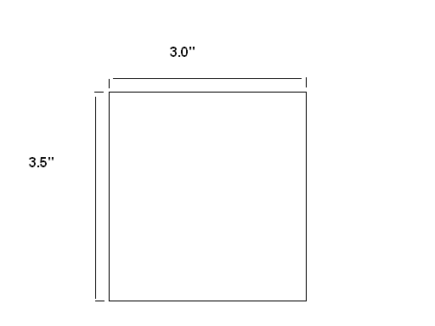
Cut six or seven vertical strips of the film using the .25” template bar provided, making the cuts as clean as possible so as not to notch or tear the specimens.

6. Place the cut specimens on a piece of filter paper and transfer them into the electronic dessicator located next to the Instron apparatus until the specimens from all 4 films have been cut and are ready to be tested.

Operating the Instron Testing Instrument
1. Before turning anything on, locate the following features on the test column:
Emergency Stop Switch (large red knob on lower right of test column; used to stop test quickly, when safety is compromised)
Main Power Switch (rear right)
Jog Up, Jog Down, and Fine Position (moves the crosshead up and down)
Upper Limit Stop, Lower Limit Stop
(yellow with black knobs, on right of column, they limit the crosshead movement)
Reset GL (Gauge Length) (controls the Return response)
Standby, Ready
Start, Stop, Return (These operations are usually controlled with the software.)
Locate the interface box, to the left of the test column.

2. Start up and Check.
Turn on the printer (check paper supply).
Turn on Main Power Switch.
Monitor the Self-Test sequence on the interface box.
It should count down to 2 then stop.
Check that the crosshead travel limit stops are in place.
Turn on the monitor and computer.
Double click on the Merlin icon when it appears.
Click on the name of the test method: Film-0.25in. Wait. The Merlin Screen will appear.
Click on Load Frame icon (to the right of the live digital displays). Check that "Below crosshead" is on. Click Done.
Click on Extension icon (upper right corner). Press Reset Gauge Length (digital reading will go to zero). Click Done.
Click on the Load Cell icon (to the left of the Extension icon). Select Automatic, then
Calibrate. At "Remove Load from Load Cell" click OK. Wait. When complete, click Done.

3. Running the sample.
As you prepare to test each specimen, measure the film thickness to 0.0001" using the micrometer.

Check "Pretest Sample" settings: Speed 2 in/min, number of specimens in sample (enter the number of specimens of that film that you have prepared), assign your sample a name, enter an operator ID, enter the temperature and humidity, assign a specimen name, width (0.25 in), thickness (as measured), length (2 in.) [Note. This is the gage length (separation of grips), not the full length of the film.]
When OK click Continue. [Throughout the testing, a message will appear: "You have not
accepted every field…" Check that the fields are correct then click Yes.]

Check "Specimen" settings. Change Specimen name as desired.
If OK click Start Test.

Follow the instructions, "Install the specimen, then click OK", as follows:
The sample should hang vertically. There should be no significant slack.
The tensile strength digital display may not read zero, but should not be significantly large.
When the specimen is installed, click OK.
During the test, if the graph goes off scale, click the Rescale Icon on the graph screen, to the left of the printer icon.
At specimen break, follow instructions to remove the specimen and click OK to return the crosshead. Check that the specimen is entirely removed from the grips.
After each test, the used specimen may be discarded
For additional specimens, click Continue on Test Director. Add Comment on previous specimen if desired. Then click Continue.

Change Specimen Name as desired. Measure the thickness and enter. Click Start Test.

After the last specimen has been run, and the results have appeared in the Results table, print the report.

4. Printing the Report.
Click on the Report icon (bottom icon on right of screen).
The Report screen will open to the report template.
Click on Printer icon, on right of Report tool bar.

5. End Testing.
Click End Sample, enter a comment if desired, then Continue.
Enter a Note if desired, then Continue.
Save as: (Name as desired but save the file in the directory that has your course name.)
Then choose either:
(A) Start New Sample, to run the specimens of your next film.
If you have just printed a report, the report screen will be showing when you start
your next run. Click the graph icon, just above the report icon, to get the graph screen.

or (after the last film sample)

(B) Start New Sample, then Save Method (from File), then Exit (from File)
Close Test Director.

6. Shut down.
Click Start/Turn off computer/Turn Off.
When the computer shuts down, turn off the monitor.
Turn off printer and testing instrument.

Data Analysis and Discussion

Determine the average and standard deviation in tensile strength and elongation at break and in modulus for the six or seven plastic strips of each film composition. Be sure to discard all measurements for any sample that exhibits tearing near the grips or has one or more of the measurements that is more than two standard deviations from the average. Tabulate these data for all of the film compositions. Make plots of tensile strength at break, of elongation at break and of modulus versus percent plasticizer. Put error bars on the points and fit the points to a straight line in cases where the lack of curvature and size of the error bars justify doing so. (There is no underlying theory that points to a linear behavior.)

Discuss the trends in tensile strength and elongation at break and modulus as a function of plasticizer content. Are the trends consistent with increasing or decreasing T_{g}? Do these treands appear to support the plasticizer contributing to polymer free volume and thus reducing T_{g}? (There have been some studies that point to certain plasticizers acting anomalously insofar as to inhibit certain aspects of polymer mobility¹⁰⁻¹²) Does the colligative behavior of the plasticizer acting as a solute on the crystalline polymer phase likely to have any bearing on your observations? Compare the tabulated properties of the agar-starch blend plastic with the pure agar plastic also containing 40% plasticizer. Firstly, consider whether the differences are significant. If so, given the starch polymer structure given below and the agar structure given in the introduction, speculate on how the polymer structures might lead to the observed results.
amylose, a major component of starch

Bibliography

- Stevens, E. S., “Green Plastics. Introduction to the New Science of Biodegradable Plastics,” Princeton University Press, New Jersey, 2002.
- American Society for Testing and Materials “Standard Test Method for Tensile Properties of Thin Plastic Sheeting” Designation D 882-01, ASTM, West Conshohocken, Pennsylvania, 2001. See also D 638-01, “Test Method for Tensile properties of Plastics.”
- Stevens, E. S.; Poliks, M. D., “Tensile Strength Measurements on Biopolymer Films,” J. Chem. Educ., 2003, 80, 810-812.
- See Introducting Polymers Across the Curriculum project website, http://www.chem.binghamton.edu/STEVENS/CCLI, in a presentation under Mechanical Engineering, entitled “Mechanical Behavior of Polymers,” by Junhyun Cho, 2004.
- Sperling, L. H. “Polymeric Multicomponent Materials. An Introduction,” Wiley & Sons, New York, 1997.
- Young, R. J.; Lovell, P. A. “Introduction to Polymers,” 2nd ed., Stanley Thones, Ltd., Cheltenham, U. K., 2000.
- Sperling, L. H. “Introduction to Polymer Science,” 3rd. ed., Wiley & Sons, New York, 2001.
- Microgalleria, Department of Polymer Science, University of Southern Missippii, “The Glass Transition,” 1995, website, http://www.psrc.usm.edu/macrog/tg.htm.
- Microgalleria, Department of Polymer Science, University of Southern Missippii, “Differential Scanning Calorimetry,” 1995, website, http://www.psrc.usm.edu/macrog/dsc.htm.
- Lourdin, D.; Bizot, H.; Colonna, P., “Antiplasticization in starch-glycerol films?,”, Journal of Applied Polymer Science, 1997, 63, 1047-1053.
- Gaudin, S.; Loudin, D.; Le Botan, D.; Ikari, J. L.; Colonna, P., “Plasticisation and mobility in starch-sorbitol films,” J. Cereal Science, 1999, 29, 273-284.
- Guadin, S.; Lourdin, D.; Forssell, P. M.; Colonna, P., “Antiplasticization and oxygen permeability of starch-sorbitol films,” Carbohydrate Polymers, 2000, 43, 33-37.

